SAE CHICAGO > SPECIAL EVENT: TOUR & PRESENTATION ON 3D PRINTING / ADDITIVE MANUFACTURING OF METAL PARTS BY RENISHAW INC. > OCT. 30

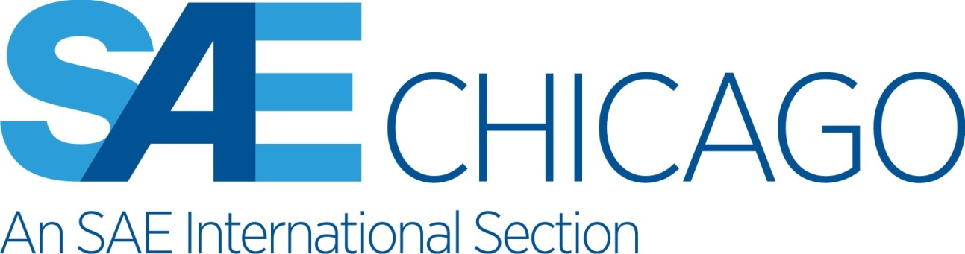

Attendance is limited to the first 25 attendees - Follow registration instructions below.
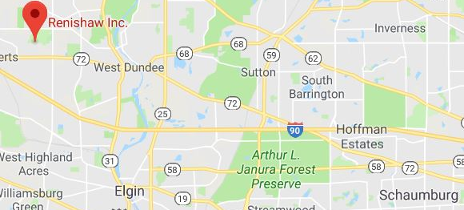
Tuesday, October 30, 2018
5:00 pm to 8:30 pm
1001 Wesemann Drive
West Dundee, IL 60118

Company info at:
http://www.renishaw.com

Agenda:
5:00 – 5:45pm Registration

5:15 – 6:45pm – Site tours. Group tours will begin as soon as 5 people attend. Further tours will commence as further groups of 5 people muster.

6:30 – 7:30 – Buffet Dinner

7:30 – 8:00 – Presentation. A Practical Guide to Designing Parts for 3D Metal Printing

8:00 – 8:30 – Presentation. A Practical Introduction to Developing Material Parameters for 3D Metal Printing

Presentation Details:

7:30 – 8:00 A Practical Guide to Designing Parts for 3D Metal Printing by Kevin Brigden
- Introduction to Design for Additive Manufacturing
  - Topology Optimization Theory
  - Design guidelines and bionic principles for Additive Manufacturing
- Design Screening for AM Suitability
  - Manufacturing Constraints
  - Part Count
  - Material Selection
8:00 – 8:30 A Practical Introduction to Developing Material Parameters for 3D Metal Printing by John Laureto

- Finding ideal processing parameters for your AM Parts
  - The choice of processing parameters used to melt and solidify the metal powder is fundamental, as the thermal history of the alloy affects both its integrity and its strength. Selecting parameters that suit the material in question and the specific component to be build are critical to the success, particularly in series production applications.
- QuantAM – Parameter Development Overview
  - A review of the iterative multi-variate parameter development process. The designed experiment approach to selection of ideal processing parameters.
- Metallographic Practices for AM
  - Validation protocols for all experimental work. Moreover, evaluation of secondary post-processing techniques to delivery serial production components fit for functional use.
To Register (Please register by October 24th):
Advance registrations for this SAE event are required online at www.chicago.sae.org or by calling the SAE-Chicago Section office at (708)745 - 5919. Professionals are $15, Students are No Charge.
Attention Professional Engineers: This event will qualify for 2.0 PDH (Professional Development Hours). A signed certificate will be available to you at the door

