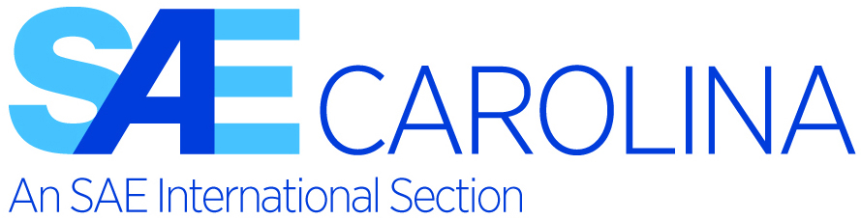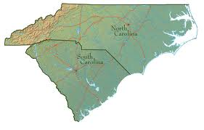

SAE International Collegiate Design Series Competition
Carolina Student Chapters Presentations
March 30th, 2023

Hendrick Motorsports Team Center
4433 Papa Joe Hendrick Blvd, Concord, NC 28262

Invitation to Company name

The SAE International Carolina Section’s Student Chapters will hold their annual “Student Night” meeting on March 30th, 2023, at the Hendrick Motorsports Team Center.

Invited universities:
UNC-Charlotte, UNC-Asheville, USC, NC A&T, Duke, NC State, Georgia Southern, Western Carolina, Citadel, and Clemson, the host school for this year’s event.

They will present and exhibit their 2022 and 2023 Baja SAE, Formula SAE Electric, Formula SAE, and SAE Aero Design projects plus other "motive engineering" projects.

The afternoon/evening activities will include project vehicles set up and on display, pizza dinner, followed by the student presentations of their vehicle design and construction details. It is estimated that ten students per team will attend, as well as their respective faculty advisor. Also all SAE Carolina section members have been invited to attend.

The SAE Carolina section invites you to attend this event, as it will be an excellent opportunity for companies to meet highly motivated engineering students from the top engineering programs in the Carolina’s, demonstrating their skills to design, build and to compete with their vehicles in the SAE competitions.

Thank you for your consideration to attend and we invite you to sponsor the Carolina Section's Student Night, making it an outstanding event for the students.
Sponsorship is available at two levels:
$250.00 Silver level  Sponsorship recognition in the SAE Carolina section meeting notice | $500.00 Gold level  Silver level plus  Available display area at the event  Recognition in all publicity materials  Opportunity to participate in judging the student team presentations.  Two complimentary event tickets

Payment options are by check or credit card at the SAE Carolina section web page: Sponsorships of the 2023 Collegiate Student Night link. Sponsor Link

SAE International is a global association of more than 128,000 engineers and related technical experts in the aerospace, automotive and commercial-vehicle industries. SAE International's core competencies are life-long learning and voluntary consensus standards development. SAE International's charitable arm is the SAE Foundation, which supports many programs, including A World In Motion® and the Collegiate Design Series.
If you have any questions or need any further information, please contact Martin Eglajs; mzeglajs.sae@gmail.com

